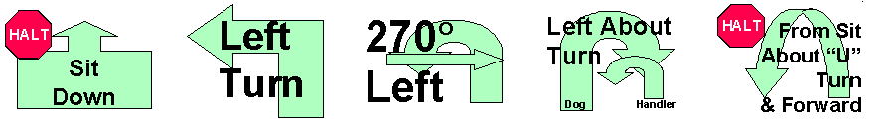

Vallejo Dog Training Club is offering a

Rally Ready Class on Saturday, December 12, 2020

Class starts at 1:00 p.m. (unless instructed otherwise in the confirmation email)

Instructor: Harriet Tucker (Obedience & Rally instructor for VDTC & SMDTC)
Cost: $15 for 2 runs, same dog

Due to current Covid 19 restrictions, only one handler/dog team allowed in the hall at a time.
Therefore, your two runs will be back-to-back, with instruction during and between the runs

The class is open to all and will include exercises at all levels of Rally

To register for this class, please email Harriet at hafpas@comcast.net
no later than the Tuesday before the class
Please bring your payment to class (cash is preferred - exact amount please)

Limited Entries – Register Early! **Pre-registration only**

Please include all the following information when you contact Harriet:
Your Name, Phone Number & Email; Dog’s Name, Breed, & Rally Jump Height
Confirmation will be emailed to you by the Thursday evening preceding the class and will include information as to when you need to arrive at the hall.

Vallejo Dog Training Club, Inc.
4740 East 2nd Street, #32
Benicia, CA 94510
707-567-7027
http://vallejodogtraining.org/

