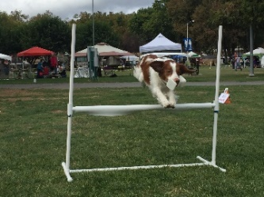 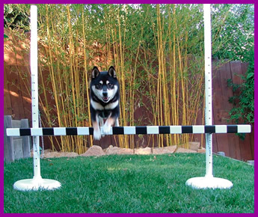 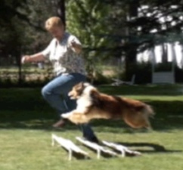 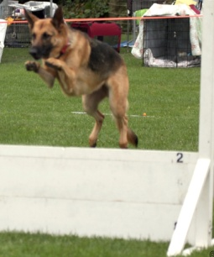 Banjo Katsu Gryphon Hank Diva

Vallejo Dog Training Club is offering
Saturday Ring Ready Obedience Classes

Practice your ring readiness at all Obedience levels

For more information about this class, contact Harriet Tucker at
hafpas@comcast.net

The dates for November and December 2020 will be as follows:
November 7 and December 5

Classes start at 1:00 p.m. (unless instructed otherwise in the confirmation email)

Each entry is allotted a specific amount of time in the ring.
Your confirmation email will indicate the time you will need to arrive at the hall.

Running order November 7 Running order December 5

Beginner Novice Utility
Novice Open
Sits & Downs (Novice) Novice
Open Sits & Downs (Novice)
Utility Beginner Novice

Place: Vallejo Dog Training Club
Cost: BN or Novice: $15 for 2 runs; Open or Utility: $15 for the 1st run, $10 for the 2nd run (same dog)
(due to Covid 19 restrictions, if you have 2 runs, they will be back-to-back, with instruction in between)

To register for these classes, please email Harriet at hafpas@comcast.net
no later than the Tuesday before the class
Please bring your payment to class (cash is preferred - exact amount please)

Limited Entries – Register Early! **Pre-registration only**

Please provide your name, phone number & email address; your dog’s name, breed, & jump height, if applicable

Confirmation will be emailed no later than the Thursday before the class

Vallejo Dog Training Club, Inc. The VDTC Saturday Ring Ready Obedience classes will be
4740 East 2nd Street, #32 conducted by Harriet Tucker, who has been training and
Benicia, CA 94510 competing in Obedience since 1996, and in Rally since its
707-567-7027 inception. She is a member of VDTC, San Mateo DTC and
http://vallejodogtraining.org/ Oakland DTC, and currently teaches for VDTC & SMDTC.

